Vienna, 3rd of Octotober 2018

Dear Madam or Sir,
I am pleased to announce that in cooperation with the International Organisation of la francophonie (OIF) a séminaire régional on «La culture comme outil diplomatique» will be held from 5-9 November 2018 at the Diplomatische Akademie Wien (DA) – Vienna School of International Studies.

This 1-week programme will combine lectures on the different dimensions of cultural diplomacy with special skills trainings in more practical areas such as conference French and negotiation training. The programme will be held in French and is targeted to the needs of:
- Officials working in ministries dealing with cultural questions
- Officials working in departments for cultural issues
- Officials working in departments for European or international affairs
- Officials working for national cultural institutes

Applications from OIF member and observer countries will be prioritized. Please find the official OIF map under: https://www.francophonie.org/Cartes-du-monde-de-la-Francophonie.html

Application is possible via our online application tool (available on our website: https://application.da-vienna.ac.at/etp/SemReg2018

Deadline of application: 1 October 2018.
The following services will be provided by the OIF and the DA*:
- tuition (organisation of the programme, invitation of highly qualified lecturers and trainers, lecture rooms at the DA with state-of-the-art technology),
- accommodation incl. breakfast at a nearby hotel (single rooms),
- lunch at the DA,
- cultural programme.
The following services will have to be provided and paid for by the sending institution:
- travel arrangements & travel costs.
*Please note that the DA/OIF cannot cover any travel costs nor per diems.

The Diplomatische Akademie Wien – Vienna School of International Studies would be most grateful if you could spread the information on this séminaire régional within your institution and partner institutions and forward it to anyone you think might be interested in this programme.

For further details please do not hesitate to contact us (viktoria.holler@da-vienna.ac.at, +43 1 505 72 72-139), we will be most happy to provide you with additional information.

Thank you for your kind assistance and best regards,
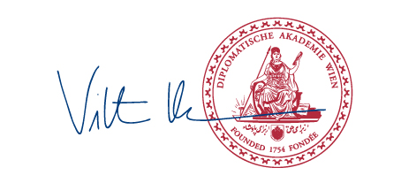
Viktoria Holler
Project Manager

