

Workshop on

WRITTEN COMMUNICATION

AND REPORTING IN ENGLISH

26 – 29 May 2015

Danilovgrad, Montenegro

**PROVISIONAL PROGRAMME**



**Background**

The Regional School of Public Administration in cooperation with the British Council, which is the United Kingdom's international organisation for cultural relations and educational opportunities, is organising a workshop on written communication and reporting in English. An ever growing number of civil servants from ReSPA region are faced on a daily basis with drafting of different documents in English, including all types of reports, for the attention of the European Union and other international organisations and partners. There is an obvious need to obtain a solid knowledge and skills on formal writing and reporting in English in order to comply with both professional and linguistic requirements.

**Objectives**

On this course you will learn to write concise and clear prose (emails, letters, reports, proposals and papers) that appeals to and communicates directly with the reader. While writing for a specific group might imply insider knowledge, we believe that reading should be a pleasure, whatever type of text it might be. We also believe that good writing can move people to action. You will develop an awareness of good writing style and have techniques and mechanisms to improve the readability and adequacy of your writing.

**Content**

You will be introduced to techniques to develop good writing skills, improve your own writing style, and practice using transformative and free writing exercises. From word choice to syntax to sentence and paragraph design, we will examine the building blocks of good writing practice and show you the choices you can make to communicate directly with your reader.

**Target Group**

Target group of the workshop are civil servants from the ReSPA Members and Kosovo* who in their work are supposed to draft different types of reports and other documents in English on a daily basis for the attention of the European Union and other international organizations. Participants are required to have good command of written and spoken English language.

**The role of the trainer and the learner**

This workshop is based on a “hands on” approach to learning. This means that you will be given various tasks to help you prepare effectively reports at a European level. You will be given various models of other European candidate countries as models to work from.

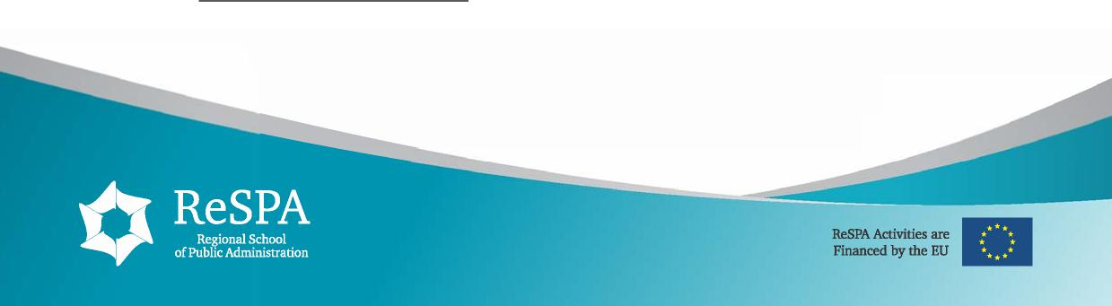

* This designation is without prejudice to positions on status, and is in line with UNSCR 1244 and ICJ Advisory opinion on the Kosovo Declaration of independence

**Therefore, the trainer will:**

✓ introduce relevant report language for the EU negotiation process

✓ provide practical tasks for you to try out language and communication skills for writing reports

✓ call on your experience and provide additional tips and advice on preparing effective reports in English

✓ highlight the importance of intercultural competency in working in a cross-cultural environment

✓ help you to evaluate your own performance with group and individual feedback

**You, the learner, will need to:**

✓ take the responsibility for learning

✓ be prepared to work in groups and actively share your opinions

✓ complete the assignments and learn from the trainer’s feedback

✓ undertake any classroom activities

We want to maintain a relaxed atmosphere on the course - if you have any problems or special requests please feel free to talk to the trainer.

**Methodology**

We believe that teaching should be learner-centred and should help participants develop strategies that work both inside and outside the classroom. We recognise that beneficiaries have different aims, world knowledge, learning styles and experiences and that motivation is crucial to successful learning.

We seek to create an enjoyable learning environment in which participants develop their language, learning and study skills in order to enable them to use English in as wide a variety of situations as possible. At the same time, we work to provide opportunities for personal and professional development.

We value the different approaches, styles, techniques and personalities that each teacher brings to the classroom and encourage teachers to innovate, experimenting with new ideas and activities.

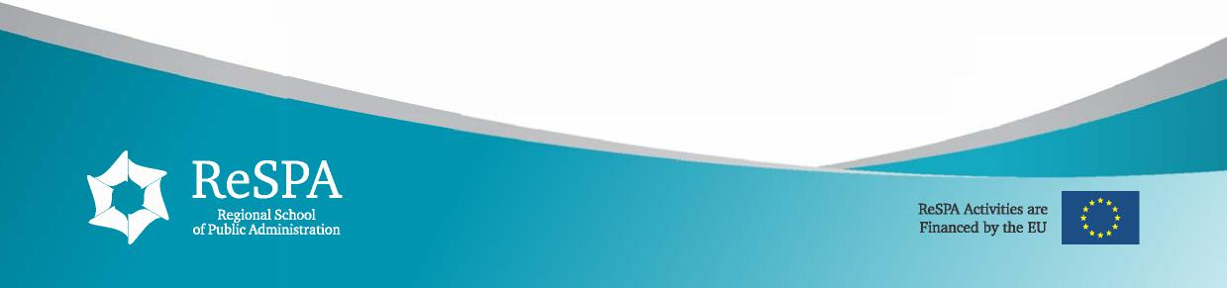

**Workshop Trainers**

**Nick Gibbs** has 20 years experience as a Communications Trainer in a range of countries across Europe and Asia, including Italy, the Czech Republic, Indonesia and Costa Rica. He is currently based in Brussels, working largely with the Belgian Government on communications training projects for the Civil Service and Diplomatic corps, and capacity-building EU communications skills projects in the Western Balkans and Turkey with the British Council. In addition, Nick is also Language Professor at The College of Europe, Bruges and Universitaire Catholique de Louvain.

**Mira Komlenovic** is an experienced trainer and facilitator with over thirty years of professional experience in the region. An expert in training of trainers, course design, training and facilitation and material development. Key areas of expertise: adult training methodology, intercultural skills and citizenship, communication skills, English language, professional skills (effective presentations, writing and formal correspondence, telephone communication, productive meetings, negotiations, lobbying, project idea development, team dynamics, interpersonal communication and relationship management). A Neurolinguistic Programming (NLP) practitioner with an extensive network of contacts and clients across Europe and in various sectors (government, NGO, education, culture, international organizations, corporate sector).

**DRAFT TRAINING PROGRAMME Day 1 − Tuesday, 26 May 2015**

09:00 – 10:30 Feedback – short report writing

Overview of Modern Writing Style 1: Positive and Personal

*10:30 – 10:45 Coffee break*

10:45 – 12:30 Overview of Modern Writing Style 2: Concise and Clear

*12:30 – 13:30 Lunch break*

13:30 – 15:00 Writing Effective E-mails: Planning and structure of e-mails and

letters

*15:00 – 15:15 Coffee Break*

15:15 – 17:00 Writing Formal Communications – Tone and Register



**Day 2 − Wednesday, 27 May 2015**

09:00 – 10:30 Feedback – Language Points from Day 1

Report Writing – The key elements of effective writing: Target Audience, Organization

*10:30 – 10:45 Coffee break*

10:45 – 12:30 The key elements of effective writing: Conciseness and Clarity –

Writing in Plain English 1

*12:30 – 13:30 Lunch break*

13:30 – 15:00 The key elements of effective writing: Conciseness and Clarity –

Writing in Plain English 2

*15:00 – 15:15 Coffee Break*

15:15 – 17:00 The key elements of effective writing: Conciseness and Clarity –

Writing in Plain English 3

**Day 3 − Thursday, 28 May 2015**

09:00 – 10:30 Feedback – Language Points from Day 2

Coherence 1: Paragraphing & Linking

*10:30 – 10:45 Coffee break*

10:45 – 12:30 Coherence 2: Connectors

*12:30 – 13:30 Lunch break*

13:30 – 15:00 Use of Register – Latin v Saxon Abstract v Concrete Useful

Language

Useful Websites & Writing Guides

*15:00 – 15:15 Coffee Break*

15:15 – 17:00 Emphasis and Punctuation

Readability & the Gunning Fog Index Editing

**Day 4 – Friday, 29 May 2015**

09:00 – 10:30 Feedback – Language Points from Day 3

Report Writing – Free Practice 1

*10:30 – 10:45 Coffee break*

10:45 – 12:30 Report Writing – Free Practice 2

*12:30 – 13:30 Lunch break*

13:30 – 15:00 Report Writing: Final Feedback

Course Summary

*15:00 – 15:15 Coffee Break*

15:15 – 17:00 Evaluation and certificates

