

Workshop on

NEGOTIATION SKILLS AND

EFFECTIVE USE OF ENGLISH

IN NEGOTIATIONS



23 – 26 June 2015

Danilovgrad, Montenegro

PROGRAMME

Background

The Regional School of Public Administration in cooperation with the British Council, which is the United Kingdom's international organisation for cultural relations and educational opportunities, is organising a workshop on negotiating in English. An ever growing number of civil servants from ReSPA region are faced on a daily basis with working in English with both European and non-European organizations and partners. This communication involves a certain amount of negotiation in order to reach an agreement which benefits both sides and creates a positive and constructive working environment. There is an obvious need to obtain a solid knowledge and skills on negotiating in English in order to comply with both professional and linguistic requirements.

Objectives

On this course you will look at modern trends in negotiation theory and put them into practice directly in the form of a series of role-plays. Your own knowledge and experience of the subject will also be of utmost value in group discussions and exchanging best practices. Alongside the skills involved in negotiating you will develop an awareness of the difference in formality of the English language in conveying a message directly or indirectly, allowing you to decide on the effect you wish to create in the negotiation.

Content

You will be introduced to the varying stages of a negotiation and develop techniques to respond to and participate in these stages effectively. You will improve your own awareness of your negotiating style through a series of role-plays. Each role play will have an observer, either the trainer or trainee, who has a list of criteria to observe and comment on at the end of the activity. The debriefing process is of great importance and you will be given advice on how to do this constructively in order to support each other in the learning process. The final task will combine all the modules of the workshop into one European Working Group meeting simulation.

Target Group

Target group of the workshop are civil servants from the ReSPA Members and Kosovo* who in their work need to, or will need to, negotiate in English on a daily basis with the European Union and other international organizations. Participants are required to have a good command of written and spoken English.

The role of the trainer and the learner

This workshop is based on a “hands on” approach to learning. This means that you will be given various tasks to help you perform effectively at a European or international level. You will be given various situations to role play.

*This designation is without prejudice to positions on status, and is in line with UNSCR 1244 and ICJ Advisory opinion on the Kosovo Declaration of independence.

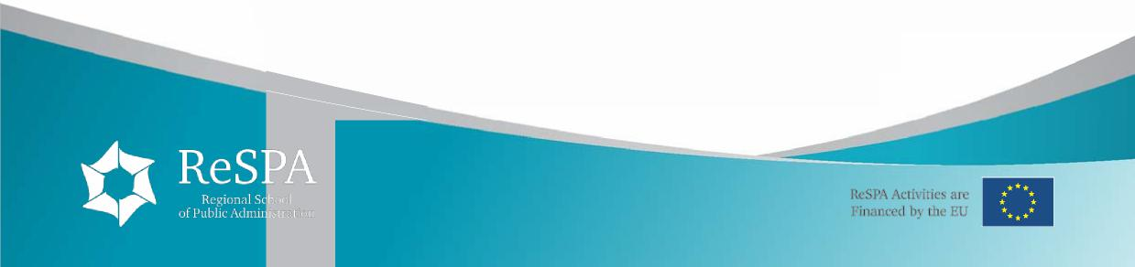

**Therefore, the trainer will:**

▪ introduce relevant diplomatic language for international negotiations

▪ provide practical tasks for you to try out language and communication skills for participating in international negotiations

▪ call on your experience and provide additional tips and advice on preparing for working as a successful negotiator in English

▪ highlight the importance of intercultural competency in working in a cross-cultural environment

▪ help you to evaluate your own performance with group and individual feedback using a video camera where necessary.

**You, the learner, will need to:**

▪ take the responsibility for learning

▪ be prepared to work in groups and actively share your opinions ▪ complete the assignments and learn from the trainer’s feedback ▪ undertake any classroom activities

We want to maintain a relaxed atmosphere on the course - if you have any problems or special requests please feel free to talk to the trainer.

Methodology

We believe that teaching should be learner-centred and should help participants develop strategies that work both inside and outside the classroom. We recognise that learners have different aims, world knowledge, learning styles and experiences and that motivation is crucial to successful learning.

We seek to create an enjoyable learning environment in which participants develop their language, learning and study skills in order to enable them to use English in as wide a variety of situations as possible. At the same time, we work to provide opportunities for personal and professional development.

We value the different approaches, styles, techniques and personalities that each teacher brings to the classroom and encourage teachers to innovate, experimenting with new ideas and activities.



Workshop Trainers

**Louise Chamberlain** has been an English language and communication skills trainer since 1992, with experience in Turkey, Italy, Poland, Belgium, Montenegro and Bosnia. She is currently based in Brussels as a freelance trainer working largely for the British Council and the Belgian Institute for the Federal Administration delivering a variety of courses to civil servants and English language teachers both within Belgium and abroad. She is particularly interested in the area of intercultural communication and has successfully completed training courses to deliver her own intercultural training courses.

**Mira Komlenovic** is an experienced trainer and facilitator with over thirty years of professional experience in the region. An expert in training of trainers, course design, training and facilitation and material development. Key areas of expertise: adult training methodology, intercultural skills and citizenship, communication skills, English language, professional skills (effective presentations, writing and formal correspondence, telephone communication, productive meetings, negotiations, lobbying, project idea development, team dynamics, interpersonal communication and relationship management). A Neurolinguistic Programming (NLP) practitioner with an extensive network of contacts and clients across Europe and in various sectors (government, NGO, education, culture, international organizations, corporate sector).

DRAFT TRAINING PROGRAMME Day 1 − Tuesday, 23 June 2015

09:15 – 09:30 **Registration**

09:30 – 10:45 **Introductions**

**Negotiating and you Defining negotiations**

*10:45 – 11:00 Coffee break*

11:00 – 12:45 **Types of negotiation**

**Stages of negotiations** Game: Useful language **Culture and negotiation**

*12:30 – 13:30 Lunch break*

13:30 – 15:00 **Culture and negotiation cont.**

**Building rapport**

Role play 1: the power of relationships

*15:00 – 15:15 Coffee Break*

15:15 – 17:00 **The negotiation process**: opening, making proposals, counter

proposals

Role play 2: preparation

Day 2 − Wednesday, 24 June 2015

09:00 – 10:30 Role play 2: the proposal stage

**Questioning technique**

*10:30 – 10:45 Coffee break*

10:45 – 12:30 **Interests v Positions**

Role play 3: finding common ground

*12:30 – 13:30 Lunch break*

13:30 – 15:00 **Bargaining**

- ZOPA

Role play 4 – Haggling Bargaining cont.

- HIT

- BATNA

*15:00 – 15:15 Coffee Break*

15:15 – 17:00 Role play 5: the bargaining zone



Day 3 − Thursday, 25 June 2015

09:00 – 10:30 **Persuading**

Language and strategies

*10:30 – 10:45 Coffee break*

10:45 – 12:30 **Handling conflict**

*12:30 – 13:30 Lunch break*

13:30 – 15:00 **Closing the negotiation**

*15:00 – 15:15 Coffee Break*

15:15 – 17:00 **Negotiation final role play**

Prepare position

Day 4 – Friday, 26 June 2015

09:00 – 10:30 **Negotiation final role play**: preparation

*10:30 – 10:45 Coffee break*

10:45 – 12:30 **Negotiation final role play – filmed**

*12:30 – 13:30 Lunch break*

13:30 – 15:00 **Negotiation final role play** – feedback

*15:00 – 15:15 Coffee Break*

15:15 – 17:00 **Course evaluation and certificates**